Exploratory Data Analysis
City Hotel Booking Demand (H2) | CSE382 Introduction to Machine Learning
Milestone 1 — Data Preparation and Baseline Experiments
Report scope: Descriptive exploration of the original H2 dataset, prior to any cleaning, preprocessing, model fitting, or test-set analysis. All interpretations are preliminary and do not establish causality.

Executive summary
The provided H2 dataset comprises 79,330 booking records and 31 source variables. The uploaded analysis contains 11 saved figures and four summary tables. Missingness is limited to 28 cells across two variables. There are 25,902 exact repeated rows, but these should not automatically be treated as erroneous bookings without a unique booking identifier. ADR is right-skewed and contains extreme values. Cancellation prevalence is 41.73%, with strong descriptive differences across market segments and deposit types. These findings support targeted investigation and leakage-aware preparation before baseline machine-learning experiments.

Key dataset indicators
Indicator | Observed value
Rows / source columns | 79,330 / 31
Missing cells | 28 (Country: 24; Children: 4)
Exact repeated rows | 25,902 (32.65% of records)
Canceled / not canceled | 33,102 (41.73%) / 46,228 (58.27%)
ADR mean / median / maximum | 105.30 / 99.90 / 5,400
LeadTime mean / median / maximum | 109.74 / 74 / 629 days

Scope and interpretation rules
Charts reflect the original data; no observations were removed or imputed. The plotted ADR histogram and boxplot are restricted to 0–300 for legibility and therefore omit the 43 observations above 300. The stay-length histogram displays only 0–21 nights. Monthly aggregation pools arrival months across 2015–2017 despite unequal temporal coverage. Correlations describe linear associations, not causality or predictive feature eligibility.

1. Data quality
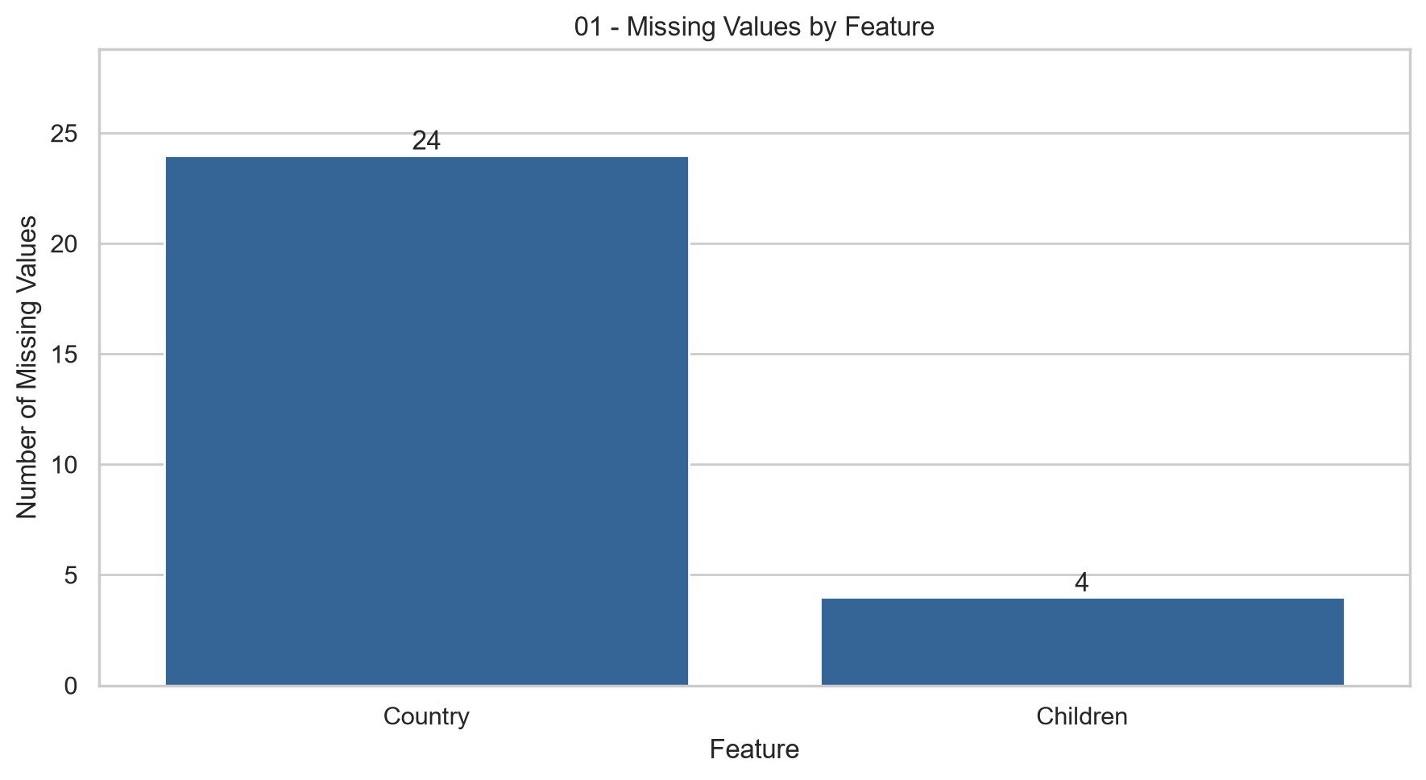
Figure 1. Missing-value counts by feature.
Only Country (24) and Children (4) contain missing entries; every other column has no missing cells. In relative terms these represent approximately 0.0303% and 0.0050% of bookings respectively. Proposed imputation must be justified and, when learned, fitted on training records only.
Duplicate audit: 25,902 rows match preceding observations across all 31 recorded columns. Because the source does not supply a unique booking ID, identical recorded attributes may describe separate real reservations. Duplicate removal remains an unresolved policy decision, not an executed cleaning step.

2. ADR: distribution and outliers
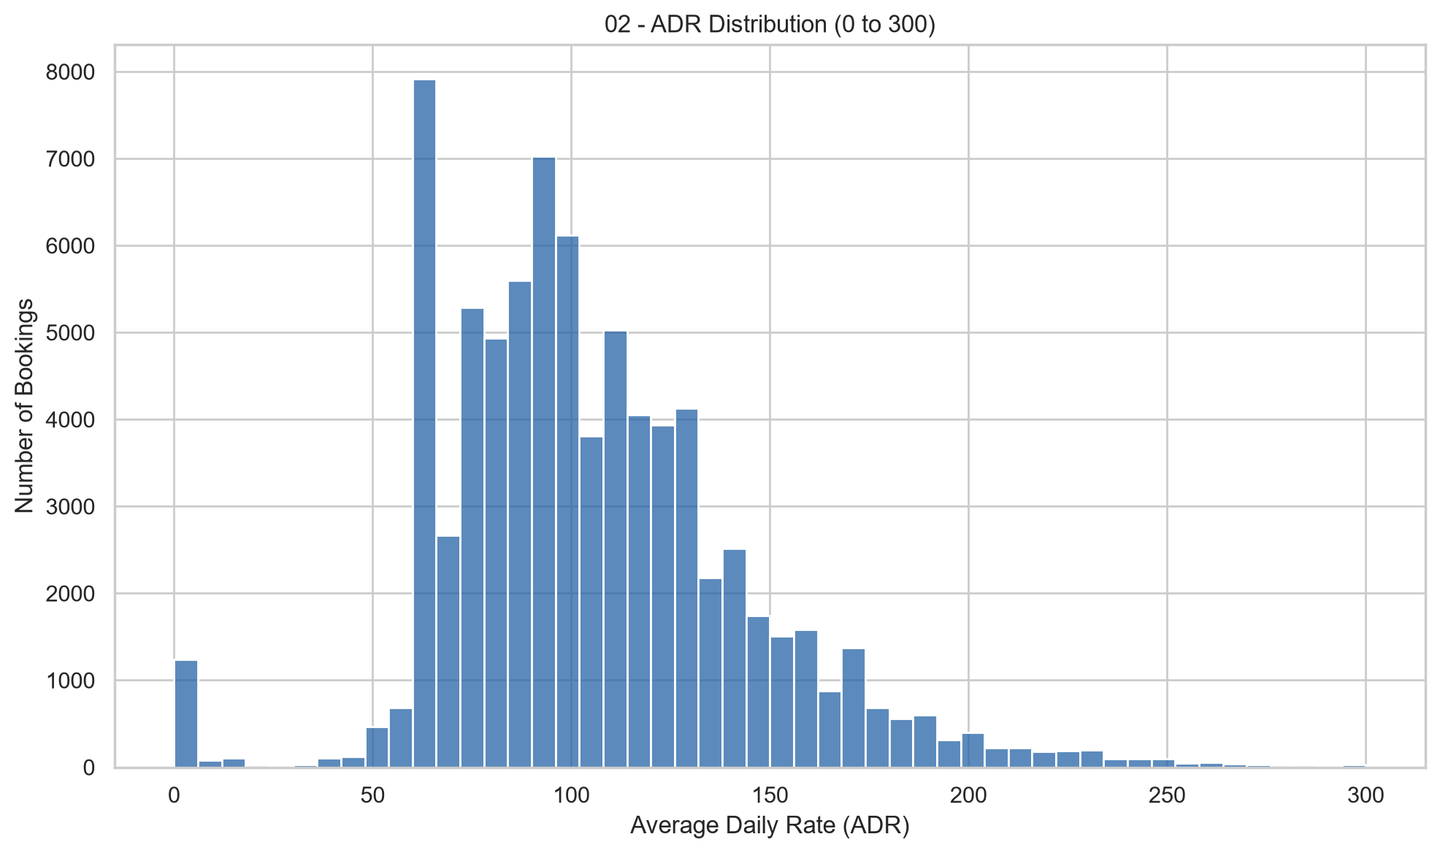
Figure 2. ADR histogram, displayed range 0–300.
Rates are concentrated in the moderate range and have a long right tail. The overall mean (105.30) exceeds the median (99.90), consistent with right-skewness. The first and third quartiles are 79.20 and 126.00. The spike at zero corresponds to 1,208 zero-ADR records, which require contextual investigation.
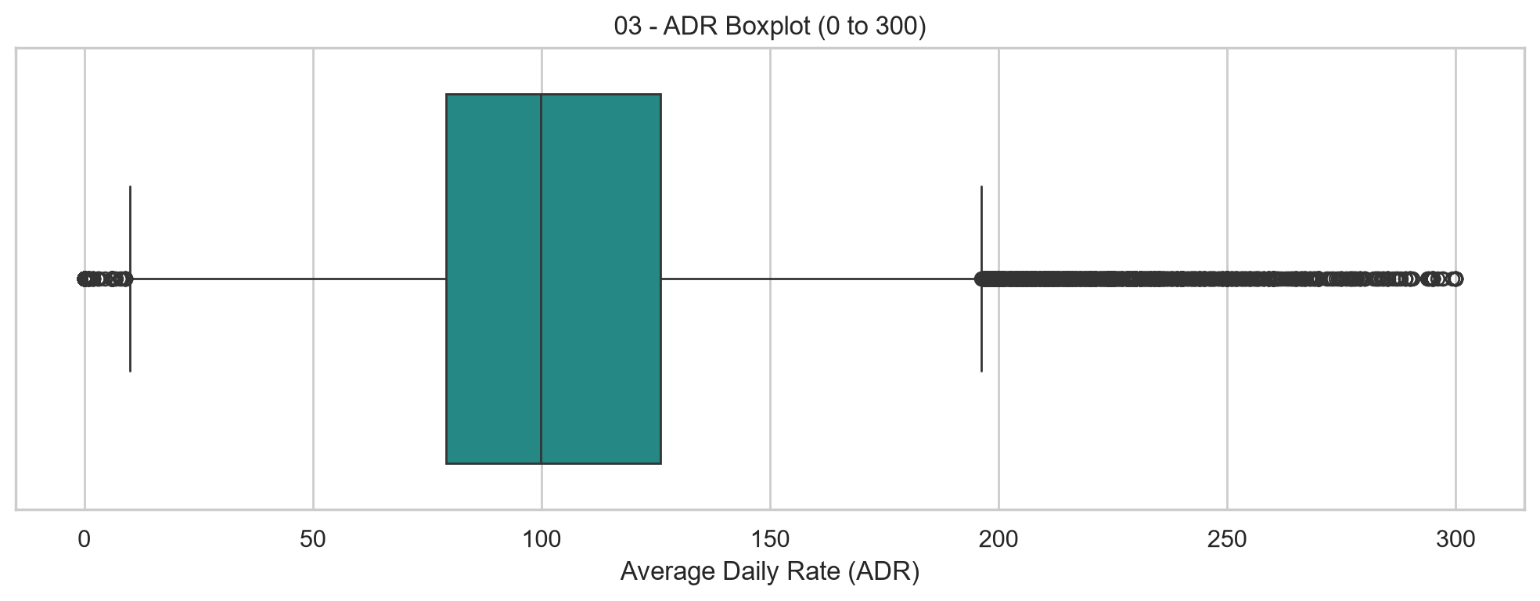
Figure 3. ADR boxplot, displayed range 0–300.
The boxplot highlights the median, middle 50% of rates, and more extreme observations. Points beyond the whiskers are statistical outlier candidates, not proof of data errors. The observed maximum across the full dataset is 5,400, compared with the next largest value of 510; this warrants case-level checking. A zero ADR can also reflect valid booking arrangements.

3. Booking behavior
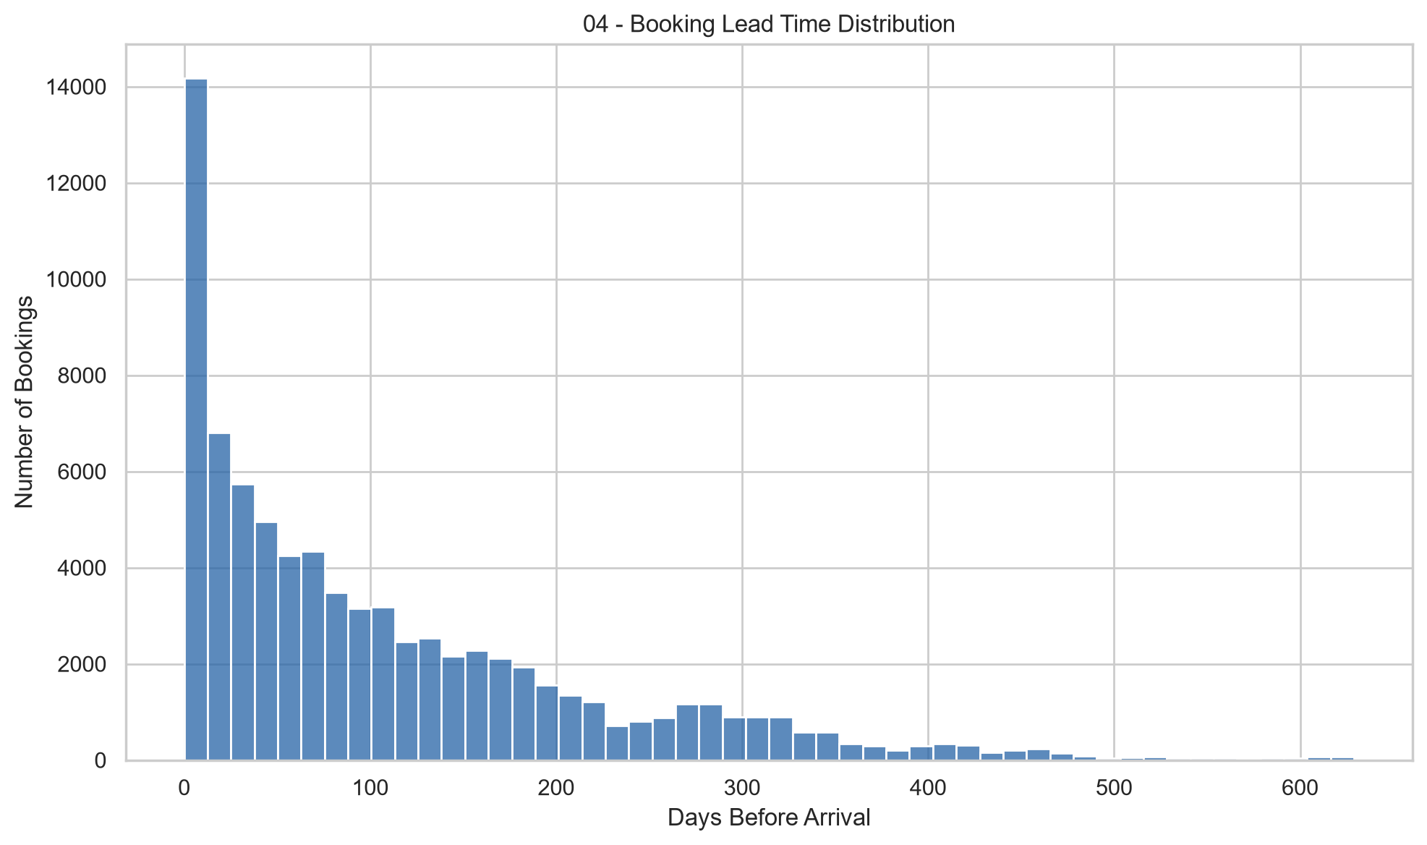
Figure 4. Lead-time distribution.
Lead times are concentrated at shorter intervals, with a long upper tail up to 629 days. Mean lead time is 109.74 days versus a median of 74 days, again suggesting right skew. Lead time could be informative for cancellation prediction, provided its timing matches the declared prediction point.
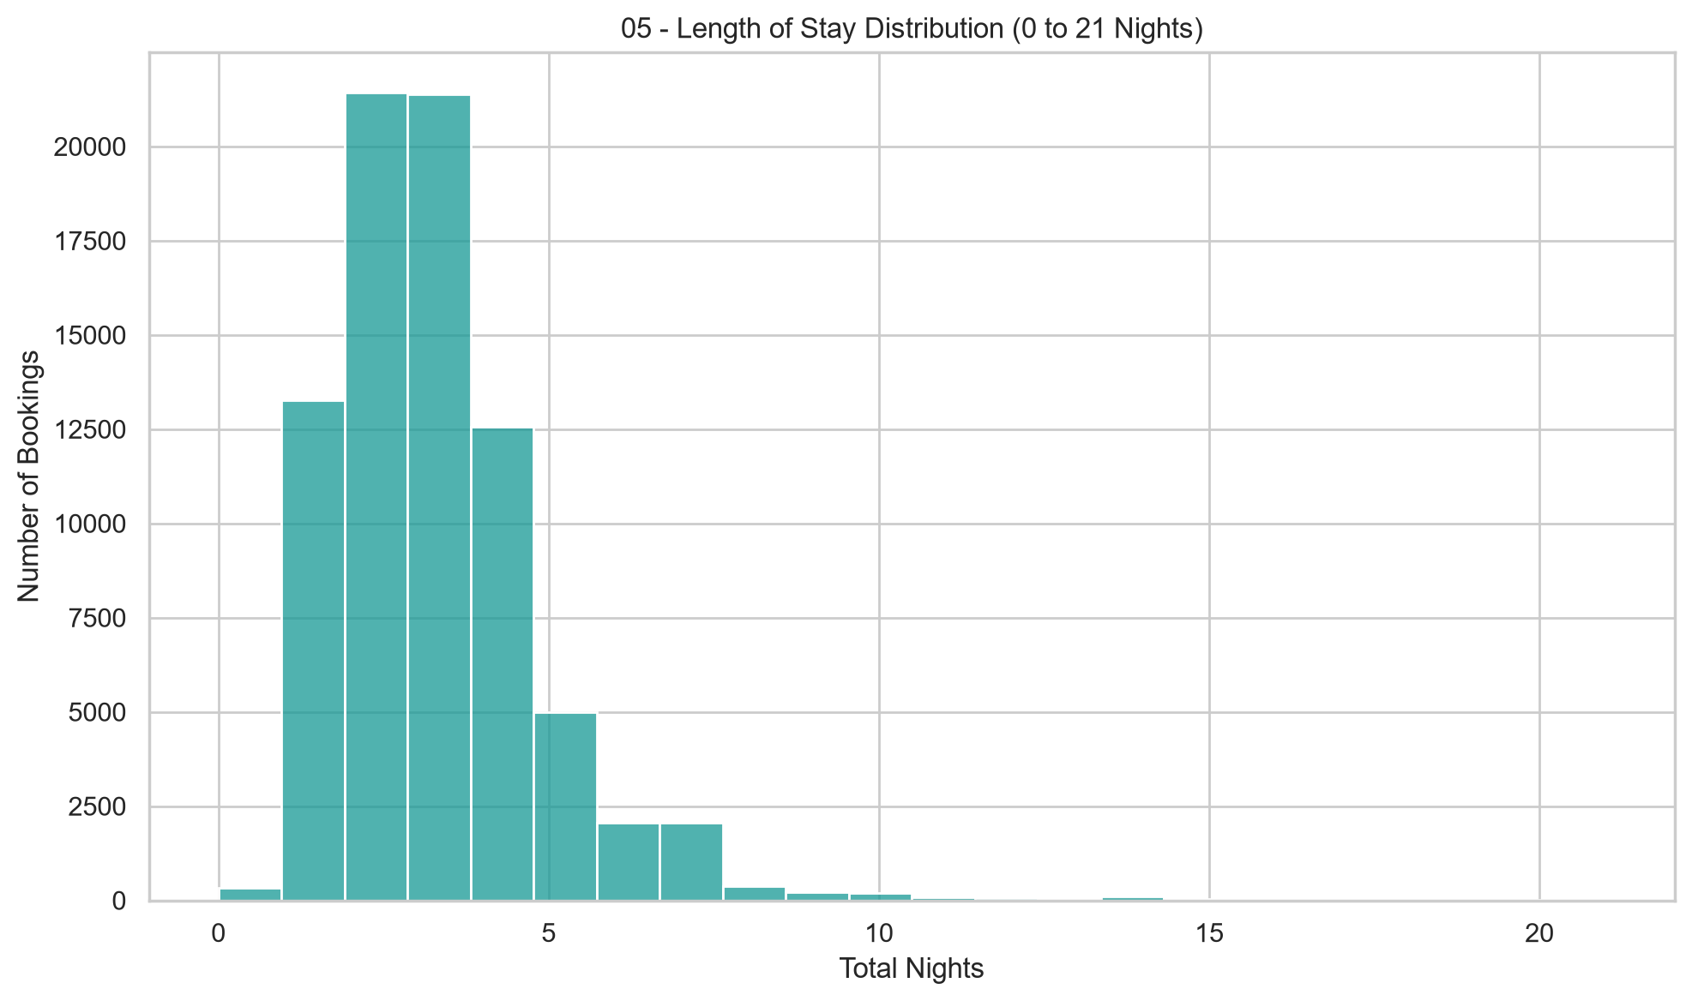
Figure 5. Length of stay, displayed range 0–21 nights.
Most reservations have relatively short stays, commonly a few nights. The graph uses StaysInWeekendNights + StaysInWeekNights; the complete data include longer stays, up to 16 weekend and 41 weekday nights separately. Zero-night stays and unusually long stays should be checked for meaning before filtering.

4. Cancellation behavior
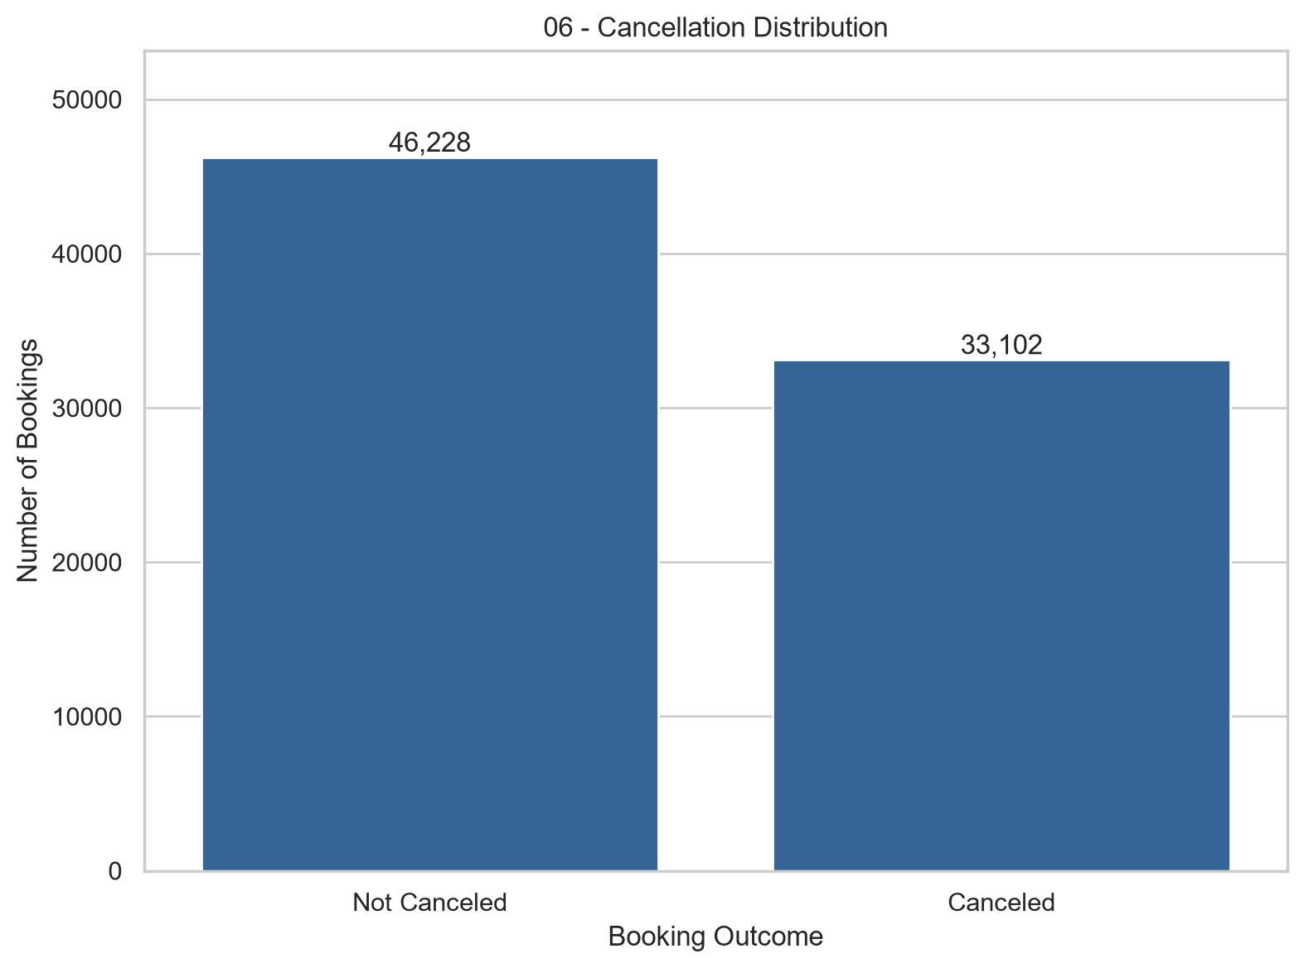
Figure 6. Cancellation class distribution.
Of 79,330 records, 46,228 are not canceled (58.27%) and 33,102 are canceled (41.73%). The outcome classes are moderately imbalanced. A trivial always-not-canceled classifier would score 58.27% accuracy on this dataset, motivating precision, recall, F1-score and suitable probability-based metrics during baseline evaluation.
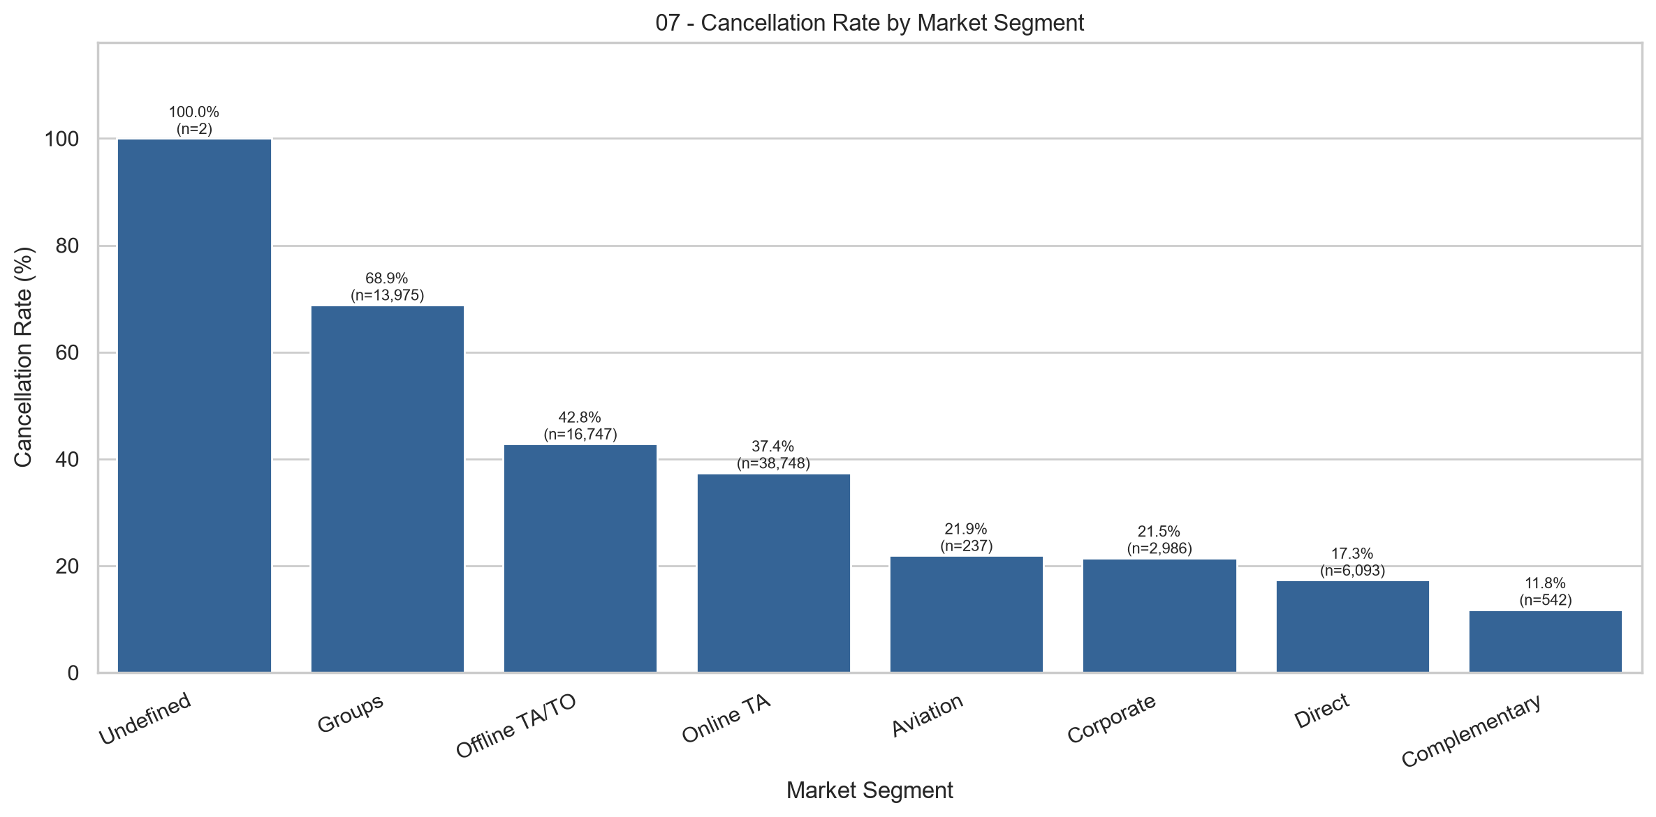
Figure 7. Cancellation percentage by market segment; sample sizes shown above bars.
Cancellation rates range from 11.81% for Complementary (n=542) to 68.86% for Groups (n=13,975); Online TA is 37.40% (n=38,748) and Direct is 17.33% (n=6,093). Undefined appears at 100%, but n=2 makes this estimate highly unstable. Differences are associations and do not establish a causal mechanism.
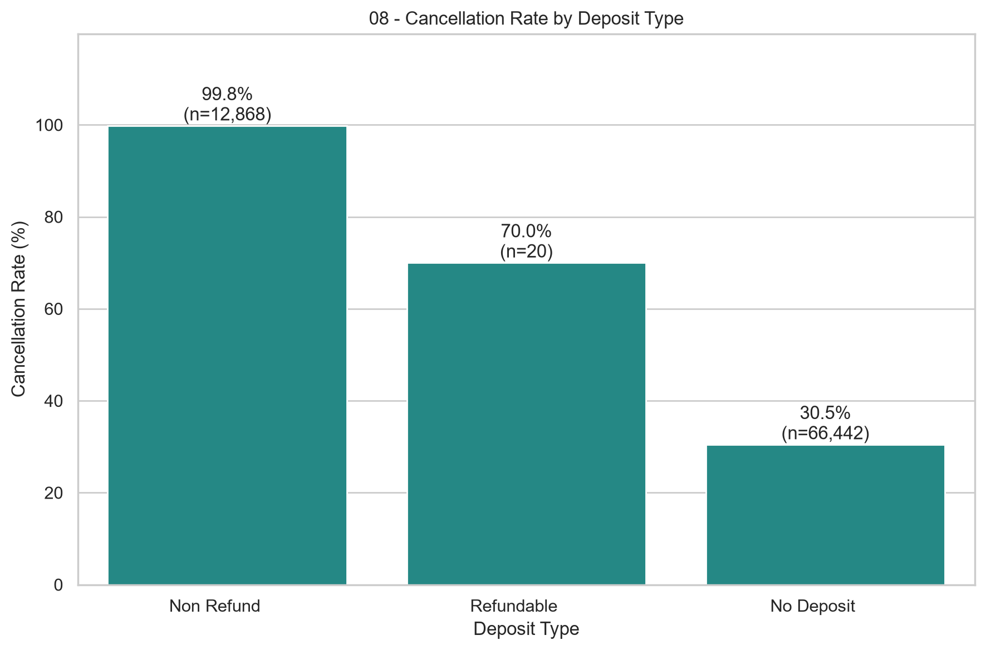
Figure 8. Cancellation percentage by deposit type; sample sizes shown.
Non Refund bookings have a 99.81% recorded cancellation rate (n=12,868), versus 30.47% for No Deposit (n=66,442). Refundable is 70.00% but includes only 20 bookings. DepositType appears highly associated with the outcome; before modeling, verify when the deposit category is recorded and whether it is available at the prediction point.

5. Seasonal patterns
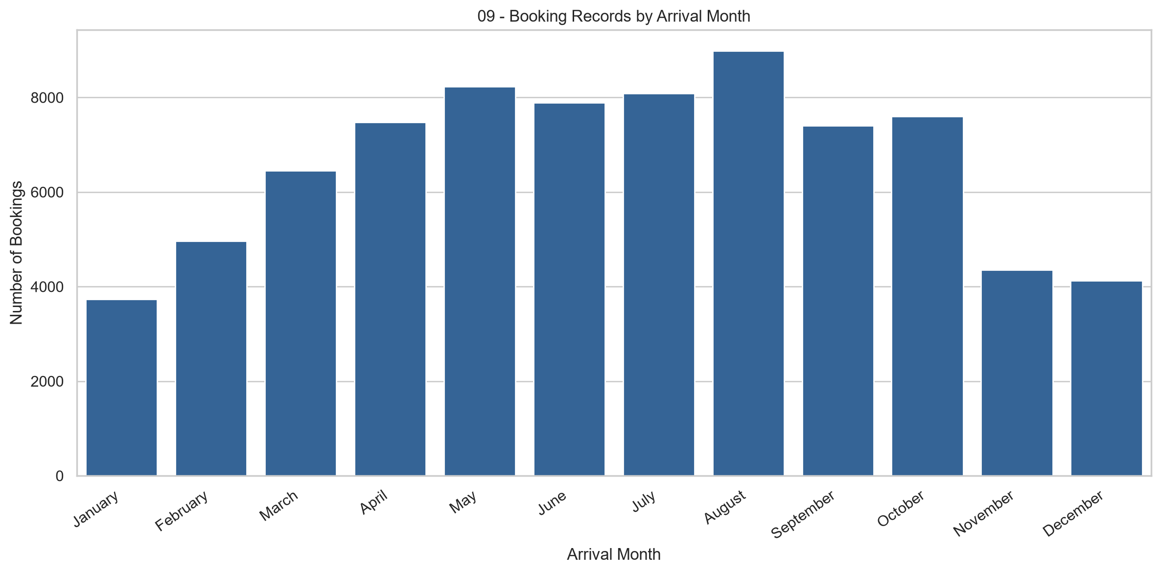
Figure 9. Booking counts grouped by arrival month.
Recorded arrival counts vary by month, with larger aggregate totals in parts of late spring through early autumn. These raw totals are not directly comparable monthly demand estimates: H2 covers July 2015 through August 2017, and the number of observed months differs. For a stronger seasonal comparison, normalize by exposure or examine month-year periods separately.
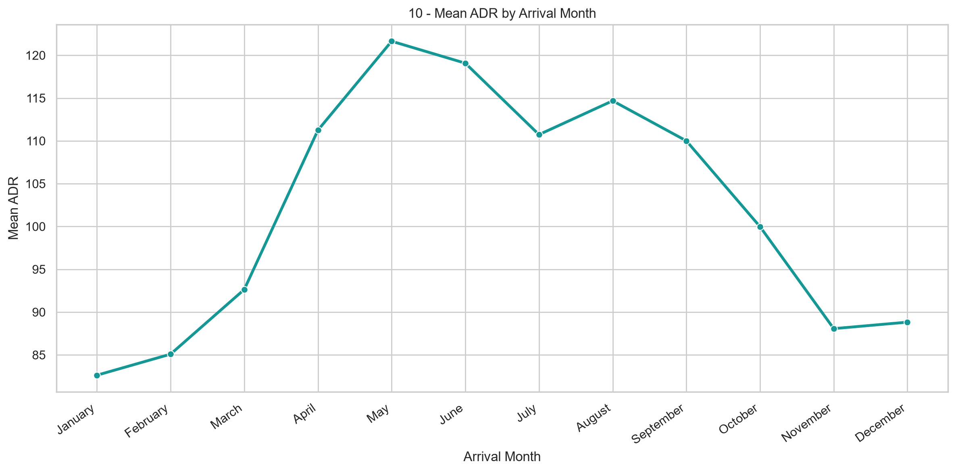
Figure 10. Mean ADR grouped by arrival month.
Average ADR shows a seasonal pattern in the pooled data, rising from lower early-year values toward a spring/summer peak and declining later. These are descriptive pooled averages, potentially affected by year mix, cancellation mix, and unequal month coverage. They do not alone prove pricing seasonality or identify the causal driver.

6. Numerical relationships
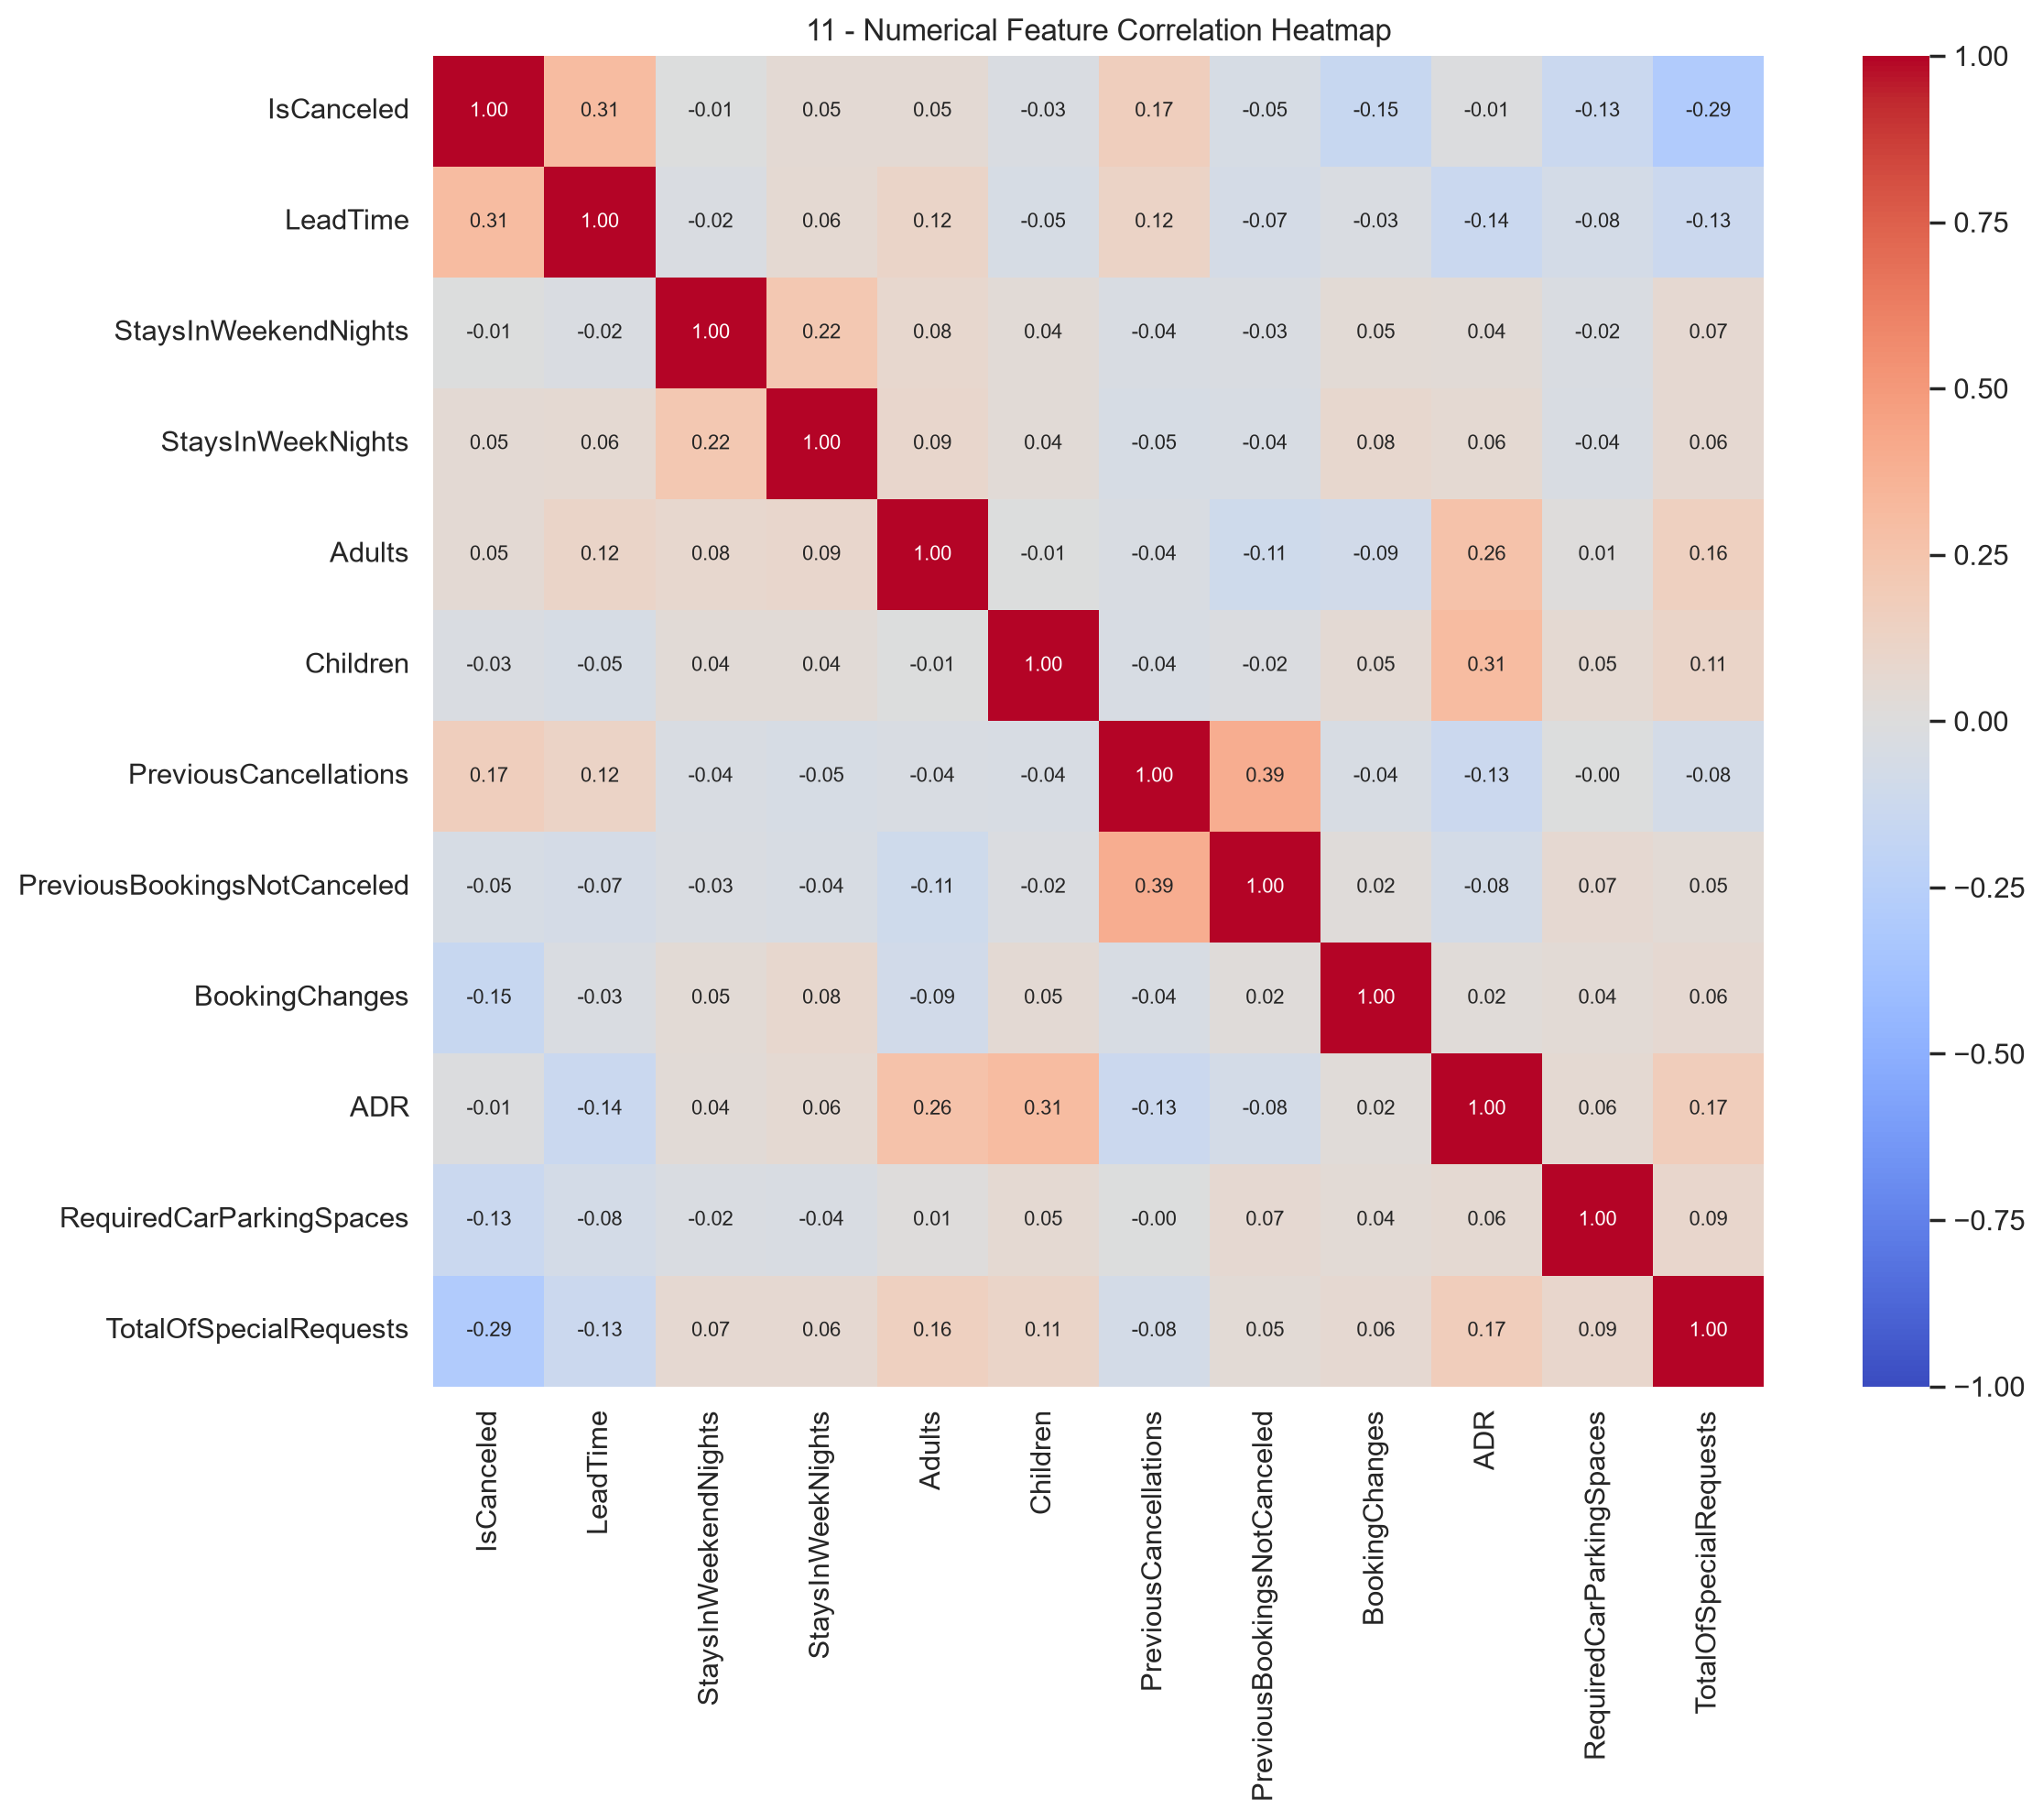
Figure 11. Pearson correlation matrix for selected numerical variables.
The heatmap summarizes direction and strength of pairwise linear associations among selected numerical columns. Correlation cannot establish causation, and values close to zero do not rule out nonlinear relationships. The target IsCanceled is included for exploratory description only; no future/outcome feature may be admitted to a predictor solely because its correlation is strong.

7. Preliminary leakage and methodological risks
Issue | Required follow-up
Outcome-derived booking status | Exclude ReservationStatus and ReservationStatusDate for pre-outcome cancellation prediction.
Later-changing booking attributes | Audit AssignedRoomType, BookingChanges, DaysInWaitingList and other fields for timing/availability at prediction point.
ADR regression target | Exclude ADR from its own input; check for directly or indirectly outcome-derived pricing features.
Data-driven cleaning / encoding / scaling | Specify train/validation/test protocol first; learn preprocessing only from training partitions.
Duplicate handling | Document the decision and test its sensitivity; do not silently discard 25,902 records.
Tiny / rare categories | Use sample sizes to avoid misleading rate comparisons, especially Undefined and Refundable.

8. Proposed next steps for Milestone 1
1. Decide and document the regression, classification and clustering analysis/prediction points and allowable attributes. 2. Reserve the final supervised test set, define train/validation or cross-validation, and use fixed seeds. 3. Implement task-specific reusable preprocessing with justified missing-value imputation, categorical encoding and numerical scaling when needed. 4. Train one untuned baseline for each of regression, classification and clustering, with preliminary metrics and interpretation. 5. Complete the GitHub team setup, individual contributions, reproducibility instructions, and milestone progress report.

9. Provenance and limitations
Evidence used in this EDA document: the eleven PNG figures and four CSV tables supplied in eda.zip; exact anomaly and booking-status counts previously produced from H2.csv during the same analysis workflow. The underlying H2.csv raw file was not included in this ZIP, so raw-data revalidation was not performed when authoring this document. All counts and charts are those provided, not independently recomputed from source bookings.
This document represents the EDA component only; it does not claim the other Milestone 1 requirements (pipelines, baseline models, GitHub contributions, progress report) are complete.

